DISTRIBUTED SYSTEMS COURSEWORK
1 A.
Client.py
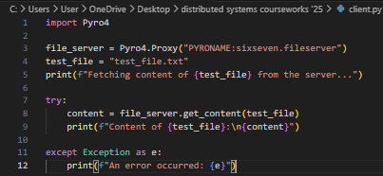
Server.py
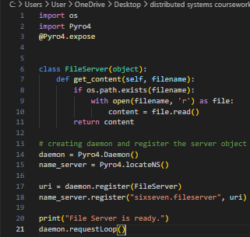
Test file
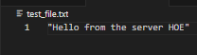

1 B.
Server.py
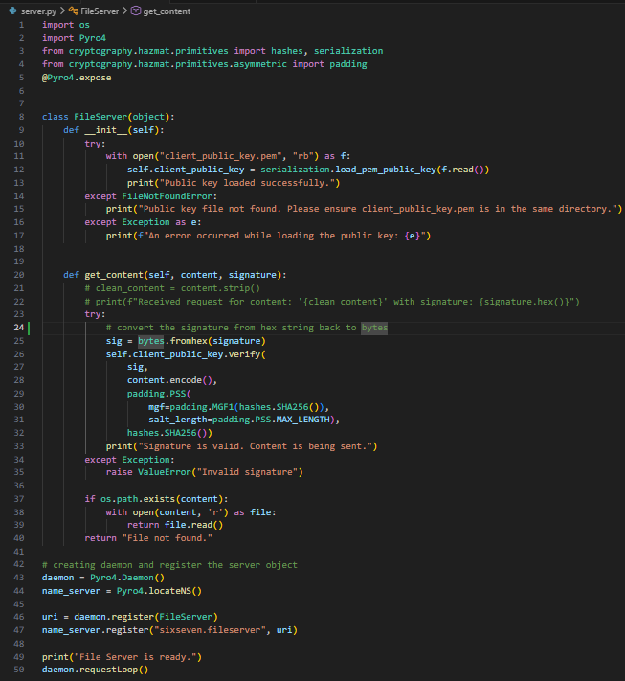

Client.py
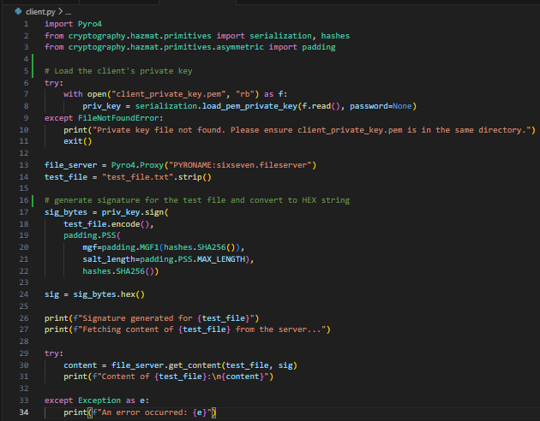
Key_gen.py
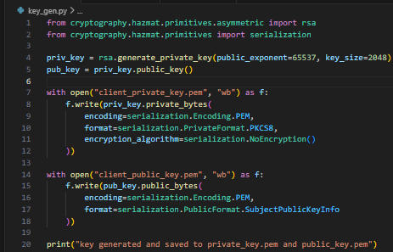

RESULTS – TERMINAL
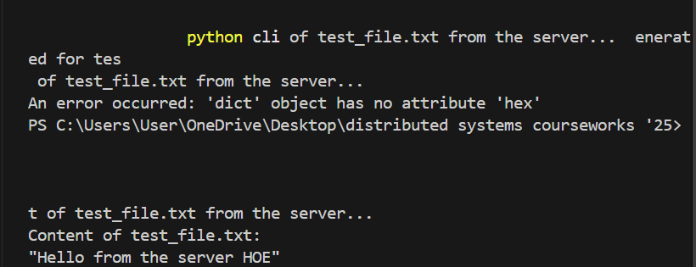
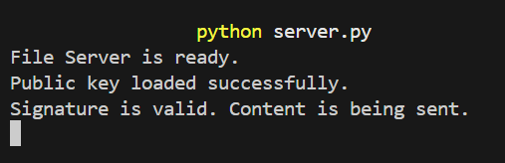
Pyro4.Proxy was used as the stub, which exists in the client and acts as a local representative for the remote object.
Pyro4.Daemon is used as the skeleton which runs on the servers and listens for new requests and calls the actual method in the server's object.
Serialization.load.pem_public_key is a method from the cryptography library that takes my plain text from the .pem files and turns them into math objects used to verify signatures.
Padding.PSS is known as the probabilistic signature scheme which is used for RSA signatures. It adds randomness to the signature process ensuring that even a duplicated signed file with look different making it harder to hack.
Hashes.SHA256() is used by the RSA algorithm.

The changes that needs to be made for a physical network are;
- Replacing the host with the actual IP address of the server computer, this allows the other systems on the same network to see it. Ex. daemon = Pyro4.Daemon(host="192.168.1.10")
- The name server lookup on the client’s side for a physical network directly tells the client exactly which computer on the network is holding the name server.
For implementation to work, the name server and the daemon must be attached to a reachable network IP address instead of the default address, and the client must be configured to a local name server using the same exact IP address as the name server and daemon, and the network firewall must be configured to permit traffic on the ports used by Pyro4.

